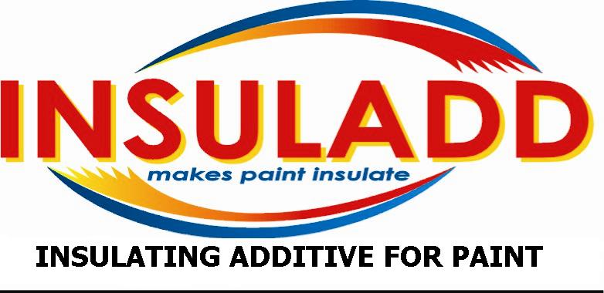

PRODUCT TECHNICAL DATA AND APPLICATION DATA

INSULADD RUSTBLOCK RADIANT BARRIER & RUST INHIBITIVE WHITE METAL PRIMER

PRODUCT DESCRIPTION

INSULADD RUSTBLOCK RADIANT BARRIER & RUST INHIBITIVE WHITE METAL PRIMER is unique industrial radiant barrier & rust inhibitive metal primer that contains INSULADD ceramic insulating materials. Specially formulated to provide superior corrosion protection when applied to ferrous metal surfaces it is an integral part of the INSULADD THERMALBLOCK RADIANT BARRIER COATING SYSTEM. Its product versatility also allows for application to a variety of ferrous metals ranging from basic usage to highly industrial metal surfaces. It is moisture resistant, easy to apply, spreads evenly, resists sagging and is abrasion resistant. Contains No Lead Pigments. FOR INTERIOR & EXTERIOR USES!

SUGGESTED PRODUCT USE

Suitable For Application To The Following Properly Prepared Surfaces:
*Piping & Pipelines * Tools * Machinery * Farm Equipment *
*Trash Dumpsters * STORAGE Tanks*
* Appliances * Ferrous Metals * Cryogenic Tanks* Gas and Oil storage tanks*
*Non-Ferrous Metal * Aluminum * Galvanized Metal* metal buildings*

PRODUCT FEATURES

* Easy To Apply * Product Versatility * Rust Inhibitive* radiant barrier*
Corrosion Resistant * Moisture Resistant
* Abrasion Resistance * Lead Free

PRODUCT SPECIFICATION DATA

* COLORS: White
* FINISH: Flat
* FLASH POINT: 106 F.
* METHOD USED: T.C.C.
* COATING V.O.C.: Not To Exceed 3.30 LB/GAL. - (400 GRAMS/LTR.)
* SOLIDS: By Volume: 54.90%
By Weight: 76.15%
* RECOMMENDED MIL FILM: Wet: 2.5 - 3.0 mils - (Estimated at 350 Square Feet Per Gallon).
Dry: 1.0 - 1.5 mils - (Estimated at 350 Square Feet Per Gallon).
* ESTIMATED COVERAGE: Covers approximately 300 - 400 square feet per gallon, depending on the type of application and the porosity of the surface to be painted.
* CLEAN UP: Mineral Spirits
* THINNING: Mineral Spirits
* ESTIMATED DRY TIME: Dries to the touch in approximately 2 - 4 hours, for recoat in 6 - 8 hours or after overnight dry, depending on conditions.

PRODUCT ANALYSIS DATA

PIGMENT: 62.81% VEHICLE: 37.19%

More Detailed Product Analysis Data Is Available Upon Formal Request.

SURFACE PREPARATION

General: The entire surface area should be clean, dry, sound and free from all dirt, grease, oils, waxes, mildew and any other surface contaminants. Bare metal surfaces should be solvent cleaned in accordance with SSPC-SP 1 specifications pertaining to surface preparation for the solvent cleaning of steel and metal surfaces for removing all visible oil, grease, soil, drawing and cutting compounds and other soluble contaminants from the surface. Remove any loose scale, chalked, cracked, peeling paint, loose mil scale and loose rust by hand scraping, sanding, or wire brush cleaning in accordance with SSPC-SP 2 or specifications pertaining to hand tool cleaning, or SSPC-SP 3 specifications pertaining to power tool cleaning of loose, non-adherent material on metal surfaces as set forth by the Steel Structures Painting Council. Repair/replace any damaged and/or delaminated surface areas.

PRODUCT APPLICATION

INSULADD RUSTBLOCK RADIANT BARRIER & RUST INHIBITIVE WHITE METAL PRIMER may be easily applied with a quality brush, roller cover, HVLP or airless spray equipment. For best results, it is recommended to apply by brush or roller cover, so to effectively work primer coating into surface pores. If applying with a brush, apply a smooth and generous coat application on/in small surface areas, such as trim, piping, or cutting-in larger surface areas. If applying with a roller cover, apply an even and generous coat application in a “M” and/or criss-cross motion, avoiding any excessive respreading or reworking. Maintain a wet edge during application by brushing/rolling into previously applied coating areas. If applying by airless spray, it is recommended to use a unit with a minimum of 2000 psi of pressure, with a 0.015 - 0.019 fluid spray tip. During spray application, it is recommended to back-roll/brush the surface area, so to work primer into surface pores, insure proper adhesion and an even coat application. Allow primer to dry thoroughly before application of recommended finish coatings. Avoid application outside when weather conditions are threatening, or late in the afternoon when there is a threat of moisture condensing on wet paint. Apply when surface and ambient temperatures are above 55 F and below 90 F.
Special Note: This Product Is Not Recommended For Use In Areas That Are Highly Corrosive, Or Chemically Contaminated. Not For Use As The Sole Primer-Finish Coating For Long Term Exterior Exposure Of Structural Steel.

PRECAUTIONS

CAUTION: COMBUSTIBLE! KEEP OUT OF REACH OF CHILDREN! Keep away from heat, sparks and open flames. INSURE PROPER CROSS-VENTILATION UNTIL COATING HAS DRIED! Where ventilation is inadequate, use a suitable respirator. Turn off main gas valve until after coating has dried, then have pilot lights re-lighted by a responsible person. Avoid prolonged contact with skin and breathing of vapors and/or spray mists. When spraying this material, use an OSHA approved cartridge respirator. Use chemical safety glasses, goggles, or a face shield for proper eye protection. After handling and before eating or smoking be sure to wash thoroughly. Close container after each use. DO NOT TAKE INTERNALLY!
FIRST AID: In case of skin contact, wash thoroughly with plenty of warm soapy water. If you get in your eyes, flush with plenty of water for 15 minutes, Seek Immediate Medical Attention! If affected by inhalation, move immediately to fresh air. If swallowed,
Do Not Induce Vomiting, Seek Immediate Medical Attention!
NOTICE: Reports have associated repeated and prolonged occupational overexposure to solvents with permanent brain and nervous system damage. Intentional misuse by deliberately concentrating the contents herein, may be harmful or fatal.

MIXING INSTRUCTIONS & PACKAGING

Stir thoroughly and apply as it comes from the container. No Thinning Is Necessary! However, if thinning is required, you may add Mineral Spirits.

* Pint Cans: N/A * Quart Cans: N/A * Gallon Cans: 4 Per Case
* Two Gallon Cans: N/A * Five Gallon Cans: Each * Weight Per Gallon: 10.36 lbs.

ALL TECHNICAL DATA INFORMATION CONTAINED HEREIN IS ACCURATE TO THE BEST OF OUR KNOWLEDGE. ALL WARRANTIES ARE EXCLUDED, WHETHER EXPRESSED OR IMPLIED BY OPERATION OF LAW OR OTHERWISE, INCLUDING ALL IMPLIED WARRANTIES OF MERCHANTABILITY OR FITNESS FOR A PARTICULAR PURPOSE. SELLER SHALL NOT BE LIABLE, (DIRECTLY OR INDIRECTLY), UNDER ANY CIRCUMSTANCES FOR CONSEQUENTIAL, INCIDENTAL, SPECIAL OR ANY OTHER TYPE OF DAMAGES ARISING OR RESULTING FOR ANY REASON UNDER THE SALE, HANDLING, OR USE OF GOODS SOLD. SELLER’S LIABILITY HEREUNDER, AND BUYER’S EXCLUSIVE REMEDY HEREUNDER, FOR NEGLIGENCE OR ANY OTHER REASON, IS EXPRESSLY LIMITED TO REIMBURSEMENT OF THE PURCHASE PRICE OF THE MATERIALS SOLD AFTER PROOF OF PURCHASE IS PROVIDED TO THE SELLER. NOTICE OF ANY ALLEGED FAILURE OR DEFECTED IN THE MATERIALS MUST BE GIVEN TO THE SELLER IN WRITING BY CERTIFIED U.S. MAIL WITHIN 15 DAYS OF FIRST NOTICING THE PROBLEM. FAILURE TO GIVE THE REQUIRED NOTICE WITHIN THE TIME PROVIDED CONSTITUTES A WAIVER OF ANY CLAIM. THE MANUFACTURER IS NOT RESPONSIBLE FOR ANY MISREPRESENTATION MADE BY THE DEALER.

Any additional information regarding our products and/or pricing is available through :
Tech Traders Inc. Toll free 888-748-5233 (772) 770-4801 www.insulatingpaints.com

